
2024 FRST EARLY SUMMER SLAM
FRANKLIN REGIONAL SWIM TEAM
May 2-4, 2025

SANCTION: | This meet is sanctioned by USA Swimming and Indiana Swimming -  Sanction Number: #IN25252
HOST: | Franklin Regional Swim Team  Zach Dewitt  3966 Berkshire Ln.,  Martinsville, IN, 46151
FACILITY: | Franklin Community High School  2600 Cumberland Drive  Franklin, IN 46131  An eight-lane 50-meter pool with seating for 750 spectators; Daktronics timing system with touchpads will be used with two 8 lane readout scoreboards. FRST intends to run the meet in lanes 1-7, using lane 8 for warm-up/warm-down for the Senior session. FRST does reserve the right to change lane configuration based on entries.  Swimmer ‘camping’ will be on deck and in designated areas.  The competition course has not been certified in accordance with 104.2.2C(4). The pool depth ranges from 5’0” to 4’O” feet.
MEET REFEREE: | David Schotting (DavidSchotting@gmail.com)
MEET DIRECTOR: | Paul Stockett (stockett@frstswimming.com)
MEET ENTRY CHAIR: | Paul Stockett  3966 Berkshire Ln.,  Martinsville, IN, 46151  entries@frstswimming.com
OFFICIALS: | The Franklin Regional Swim Team will need the help of your USA Swimming Officials. If you have officials willing to help at our meet, please provide his/her name & email address to David Schotting (DavidSchotting@gmail.com) or complete the Officials RSVP Form here.
MEET FORMAT: | The meet will be timed finals format with one session on Friday and three sessions on Saturday and Sunday.  FRST reserves the right to limit the number of entries and any event to achieve a 4-hour maximum timeline. No team will be broken if entry limits are applied. The Meet Entry Chair will notify all accepted teams of any limited events and will refund the fees for those events limited or reduced from the original entry.
ELIGIBILITY: | Swimmer(s) must be registered with USA Swimming prior to the competition.  Age as of May 2nd, 2025 shall determine the swimmer’s age for the entire meet (205.2.2).
ENTRY LIMITS: | Each swimmer will be limited to four (4) events per day and 10 total for the weekend.
ENTRY FEES: | All entry fees must be paid by Friday, May 2nd, 2025. Please make checks payable to: FRANKLIN REGIONAL SWIM TEAM. Timed finals events are $5.00 each. There is also a per swimmer, per meet, Indiana Swimming surcharge which must accompany entry. For athletes registered in Indiana, this is a $2.50 surcharge. For Out of LSC athletes, this is a $5.00 surcharge. No refunds will be made on entry fees.  Deck entries will be accepted at the discretion of the Meet Director as new additions. CHANGES WILL NOT BE ACCEPTED. The entry fee for deck entries is $10.00 per timed final event.
ENTRY DEADLINE: | No entries will be accepted before entries open. Any entries arriving before entries open will not be processed until all entries received during the entry period are processed and the entry deadline has passed. Any entries arriving after the entry deadline will be considered deck entries and are subject to that fee. The deadline may be extended if the meet is not full. All entries must arrive via e-mail. Changes, updates, and corrections (including entry times) will be accepted via email until the modification deadline. FRST reserves the right to determine which teams’ entries are accepted. FRST Reserves the right to limit the number of entries in all events to keep the timeline manageable. FRST will try to accommodate all entered teams until the meet is considered at capacity.  Entries Open: Monday, April 14th, 2025, 8:00 AM.  Entries Close: Friday, April 25th, 2024, 5:00 PM *NO adjustments after entries close
CLERK OF COURSE: | There will be a Clerk of Course for 10 and Under events ONLY.
AWARDS/SCORING: | Ribbons for places 1-8th in individual events for 14 & Under swimmers.  Age group categories for awards will be 10 & Under, 11-12, and 13-14. No awards for open events.  For individual events, points will be awarded to the top 16 places in each event per standard scoring (20-17-16-15-14-13-12-11-9-7-6-5-4-3-2-1).  Coaches should pick up awards at the end of the meet. No awards will be mailed.
WARM-UP: | Lanes for warm-ups will be assigned. A complete schedule of lanes and times for all warm-up procedures must be adhered to by all participants and will be posted at the facility during the meet
SCHEDULE: | Our schedule will be somewhat flexible and subject to change based on entries. We will have session capacity limits, so we reserve the right to change session times and potential age groups during sessions.  FRIDAY  - 11-12, 13-14 & Open Age Groups  - Warm-Ups Start NOT BEFORE 4:00 PM  - Meet Starts NOT BEFORE 5:00 PM  SATURDAY & SUNDAY AM: Open  - Warm-Ups Start Not Before 6:30 AM  - Start Not Before 8:00 AM  SATURDAY & SUNDAY Mid-Day: 10 & Unders  - Warm-Ups Start Not Before 11:15 AM  - Start Not Before 12:00 PM  SATURDAY & SUNDAY PM: 11-14  - Warm-Ups Start Not Before 2:00 PM  - Start Not Before 3:00 PM  Please note: All Times Are Eastern Daylight Savings Time. The meet will NOT be slowed for swimmers swimming in multiple age groups.
CONCESSIONS: | Food Trucks or concession stands will be made available to athletes and spectators.  A hospitality area will be available for coaches, officials, and volunteers.
ADMISSION: | Admission of $6.00 per person for each session will be charged. There will also be an all-day pass sold for $10.00 and an all-weekend pass for $20.00. Children 10 and under are free.
SALES: | Aquatic outfitting vending will be provided by a local vendor, selling items from suits to goggles. FRST also expects multiple other vendors to be available.
PSYCH SHEETS: | Psych sheets will be posted to the meet website by Wednesday at noon before the start of the meet. Heat sheets will be available for purchase at the meet for $2.
PARKING: | Free parking will be available in the parking lot on the east and south sides of the high school. Parking lots labeled senior parking lots should be used. Signage will be available to instruct on where to park, as other events will be taking place at the high school. Please use door #14 (Athletic Entrance) to enter.
FACILITY NOTE: | Franklin Community High School is a tobacco-free facility.  The Franklin High School Aquatic Center is one of the most beautiful high school facilities in the USA. It is important that all people attending this meet, whether it is swimmers, coaches, or spectators, treat this facility with the utmost care. The following rules will be strictly enforced:  - Keep all trash picked up (swimmers and teams in particular).  - Do not go, or let children go, in any unauthorized areas. Please keep children supervised at all times.  - Due to USA Swimming insurance requirements, ONLY swimmers, coaches, officials, and volunteers are allowed on deck. There can be no exceptions!  - No radios, balls, or anything that will be an inconvenience to swimmers, coaches, officials, workers, will be allowed.  The Franklin Regional Swim Team will have volunteers roaming the deck and locker room areas. If any swimmer is caught abusing the building or facility, they will immediately be asked to leave the meet and will be barred from further competition.
MEDICAL: | There will be lifeguards on duty throughout the course of the meet with access to first aid supplies and an AED.
RULES: | Current USA Swimming and Indiana Swimming rules, including MAAPT 2.0, will govern this meet.  At a sanctioned competitive event, USA Swimming athlete members must be under the supervision of a USA Swimming member coach during warm-up, competition, and warm-down. The Meet Director or Meet Referee shall assist the athlete in making arrangements for such supervision, but it is the swimmer’s responsibility to make such arrangements prior to the start of the meet.  Any swimmer entered in the meet, unaccompanied by a USA Swimming member coach, must be certified by a USA Swimming member coach as being proficient in performing a racing start or must start each race from within the water. It is the responsibility of the swimmer or the swimmer’s legal guardian to ensure compliance with this requirement.  Coaches and Officials MUST display their current USA Swimming coach credential or Deck Pass to gain deck access. The meet referee and/or meet director reserves the right to ask for coach credentials or Deck Pass and/or deny deck access if a coach or official does not comply or a card is no longer valid/current.  In swimming competitions, the competitor must wear only one swimsuit in one or two pieces except as provided in USA Swimming rule 205.10.1. All swimsuits shall be made from textile materials. For men, the swimsuit shall not extend above the navel nor below the knees, and for women, shall not cover the neck, extend past the shoulder, nor extend below the knee.  Use of audio or visual recording devices, including a cell phone, is not permitted in changing areas, restrooms, or locker rooms  Deck changes are prohibited.  Operation of a drone, or any other flying apparatus, is prohibited over the venue (pools, athlete/coach areas, spectator areas, and open-ceiling locker rooms) any time athletes, coaches, officials, and/or spectators are present. Exceptions may be granted with prior written approval by the Program Operations Vice-Chair.
SAFE SPORT 360: | The Minor Athlete Abuse Prevention Policy prohibits Applicable Adults (as defined) from having one-on-one interactions with minor athletes who are not within an observable and interruptible distance from another adult. Applicable Adults are required to abide by this policy in full during this meet.  Pursuant to USA Swimming Rules and Regulations and federal law, it is every member’s responsibility to immediately (i.e., within 24 hours) report any incident of child abuse, including physical or sexual abuse, to law enforcement and the U.S. Center for SafeSport. Reporting must occur when an individual has firsthand knowledge of misconduct or where specific and credible information has been received from a victim or knowledgeable third party. A report to the U.S. Center for SafeSport may be made via telephone at 720-531-0340 or online at www.uscenterforsafesport.org/report-a-concern. Various state laws may also require reporting to law enforcement or to a designated child protection agency.  All athletes age 18 and older must complete Athlete Protection Training in order to be a USA Swimming registered member in good standing. Any athlete who turns 18 on or after April 2, 2025, who has not completed Athlete Protection Training by the first day of competition, will be prohibited from participating in the competition until such time as all membership requirements are completed. Times achieved by an athlete who turns age 18 on or after April 2, 2025, who competes in this USA Swimming sanctioned event without completing this membership requirement, will NOT count for qualification or recognition. This includes participation as a member of a relay.

Order of Events
Friday May 2nd, 2025
Session #1: 11 & Over Timed Finals Distance
Warm-Ups @ 4:00 PM*
Meet Starts @ 5:00 PM*
1 |  |  |  | Open 400 IM | 2
3 |  |  |  | 13-14 400 IM | 4
5 |  |  |  | 11-12 200 IM | 6
7 |  |  |  | Open 400 Freestyle | 8
9 |  |  |  | 13-14 400 Freestyle | 10
11 |  |  |  | 11-12 400 Freestyle | 12
Saturday May 3rd, 2025
Session #2: Open Timed Finals  Warm-Ups @ 6:30 AM*  Meet Starts @ 8:00 AM* |  |  | Session #3: 10 & Under Timed Finals  Warm-Ups @ 11:15 AM*  Meet Starts @ 12:00 PM* |  |  | Session #4: 11-14 Timed Finals  Warm-Ups @ 2:00 PM*  Meet Starts @ 3:00 PM*
13 | Open 200 Freestyle | 14 | 23 | 10 & Under 200 Freestyle | 24 | 33 | 13-14 200 IM | 34
15 | Open 100 Backstroke | 16 | 25 | 10 & Under 100 Backstroke | 26 | 35 | 11-12 100 Freestyle | 36
17 | Open 50 Freestyle | 18 | 27 | 10 & Under 50 Breaststroke | 28 | 37 | 13-14 100 Freestyle | 38
19 | Open 100 Butterfly | 20 | 29 | 10 & Under 100 Butterfly | 30 | 39 | 11-12 100 Breaststroke | 40
21 | Open 200 Breaststroke | 22 | 31 | 10 & Under 50 Freestyle | 32 | 41 | 13-14 100 Breaststroke | 42
 |  |  |  |  |  | 43 | 11-12 100 Backstroke | 44
 |  |  |  |  |  | 45 | 13-14 100 Backstroke | 46
 |  |  |  |  |  | 47 | 11-12 50 Butterfly | 48
 |  |  |  |  |  | 49 | 13-14 200 Butterfly | 50
Sunday May 4th, 2025
Session #5: Open Timed Finals  Warm-Ups @ 6:30 AM*  Meet Starts @ 8:00 AM* |  |  | Session #6: 10 & Under Timed Finals  Warm-Ups @ 11:15 AM*  Meet Starts @ 12:00 PM* |  |  | Session #7: 11-14 Timed Finals  Warm-Ups @ 2:00 PM*  Meet Starts @ 3:00 PM*
51 | Open 200 IM | 52 | 61 | 10 & Under 200 IM | 62 | 71 | 11-12 50 Freestyle | 72
53 | Open 200 Backstroke | 54 | 63 | 10 & Under 50 Backstroke | 64 | 73 | 13-14 50 Freestyle | 74
55 | Open 100 Freestyle | 56 | 65 | 10 & Under 100 Freestyle | 66 | 75 | 11-12 50 Backstroke | 76
57 | Open 200 Butterfly | 58 | 67 | 10 & Under 50 Butterfly | 68 | 77 | 13-14 200 Backstroke | 78
59 | Open 100 Breaststroke | 60 | 69 | 10 & Under 100 Breast | 70 | 79 | 11-12 200 Freestyle | 80
 |  |  |  |  |  | 81 | 13-14 200 Freestyle | 82
 |  |  |  |  |  | 83 | 11-12 50 Breaststroke | 84
 |  |  |  |  |  | 85 | 13-14 200 Breaststroke | 86
 |  |  |  |  |  | 87 | 11-12 100 Butterfly | 88
 |  |  |  |  |  | 89 | 13-14 100 Butterfly | 90
*Times listed as not before. Times may be adjusted based on entries.

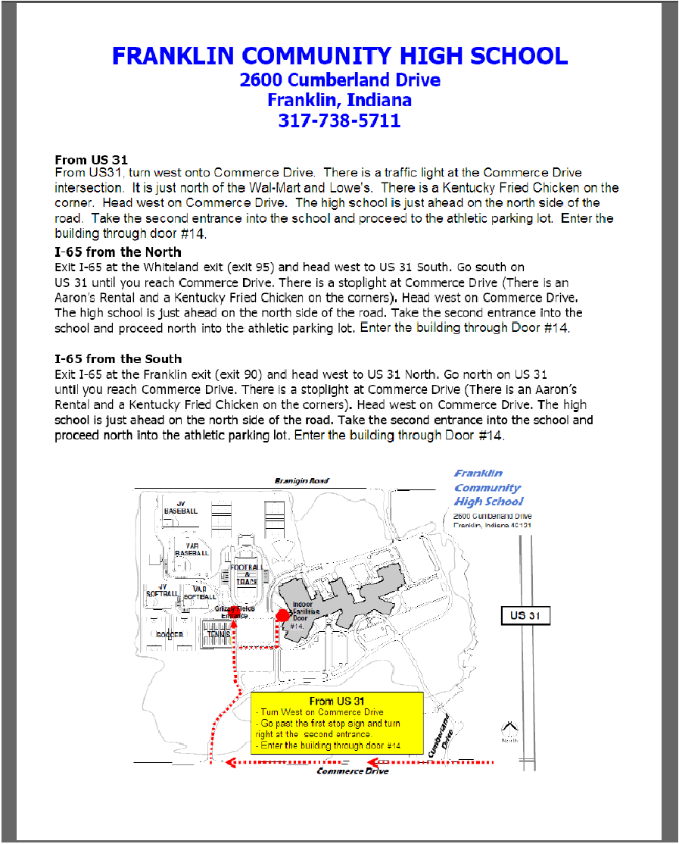

SUMMARY PAGE

Please complete the requested information below and mail with your entry forms and check. Make check payable to Franklin Regional Swim Team. If mailing, please mail a check to:

Zach DeWitt
3966 Berkshire Ln.,
Martinsville, IN, 46151

Club Name: |  |  | Club Code:
Name:
Address:
City:
State, Zip:
Phone #:
Email:

Number of Swimmers: |  | Boys + |  | Girls = |  | Total Athletes
Athlete Surcharge:
Indiana Swimming Athletes |  |  |  | Swimmers @ | $2.50 | $
Out of LSC Athletes |  |  |  | Swimmers @ | $5.00= | $
Number of Individual Timed Finals Entries: |  |  |  | Events @ | $5.00= | $
 |  |  |  | Total Amount Enclosed |  | $

Release and Hold Harmless Agreement:
In consideration of being permitted to participate in this swim meet, and for other good and valuable consideration, the undersigned, for himself, his successors and assigns, hereby releases and forever discharges Franklin Regional Swim team, USA Swimming, Franklin Community High School and each of their respective officers, agents, employees, members, successors and assigns, and all other persons in any way connected with this swim meet, from any and all liabilities, claims, demands, actions, or causes of action of whatever kind of character arising out of or in connection with said event.

Further the undersigned shall indemnify and hold harmless Franklin Regional Swim Team, USA Swimming, and the Franklin Community High School and the officers, trustees, agents, employees and members of the foregoing and all other persons in any way connected with this event, from any and all other losses, expenses, damages, demands and claims arising out of or in connection with any injury, including death or alleged injury or damage to property sustained or alleged to have sustained in connection with or to have arisen out of said event.

Executed this ___________ day of ________________________,2043

Signature of Club Official or Coach: ______________________________________

Printed Name of Signature: ____________________________________________

